|  |
| --- |
|  |
| **MULTI-FUNCTIONAL SKIN SPA SYSTEM** |
| User Manual |

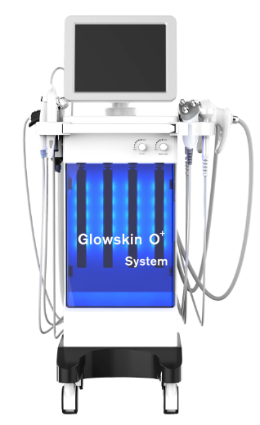

**1. Parts Introduction4**

**2. Installation4**

**3. Introduction and Operation of Each Function5**

(1) Hydrodermabraion5

Application5

Operation Steps6

(2) Oxygen Spray Treatment7

Operation Steps7

(3) Biopolar/Three polar RF8

(4) Bio Photoelctric9

Application9

Operation Steps9

(5) Ultrasonic10

Application10

Operation Steps10

(6) Skin Scrubber11

(7) Photon brush12

General introduction12

Application13

Operation Steps13

**4. Parameters14**

**5. Contraindications14**

**6. Product Service and Maintenance15**

### IMPORTANT: before starting the equipment correctly, please follow the installation instructions. Any damages caused by incorrect operations will void the warranty.

**Safety Information:**

Thank you for choosing our products! This user instruction is specially designed for the safety of you and others. Please read the instructions carefully before installing or using the machine and follow them when using.

**Electrical Safety**

Before installing the machine, make sure that your local electric network complies with the voltage and frequency indicated on the tag on the rear panel. Otherwise, the machine may be damaged incase of excessive current or voltage rise.

Never touch the machine with damp or wet hands or feet.

It is dangerous to change or try to modify the function of this machine in anyway.

Do not attempt to operate this unit if the power cord has been frayed or broken

Do not spill water or other liquids into or onto your unit.

During long periods of non-use, disconnect the unit’s main power.

**Safety Rules When Installing**

Place the machine on a stable and secure base. It should not be subjected to any jolts or vibrations.

Never expose the unit to too high(>40ºC) nor too low temperature(<5ºC).

NEVER EXPOSE THE UNIT TO RAIN OR ANY OTHER HUMIDITY.

Do not expose the unit to direct sunshine or install the unit close to a source of heat(central heating, radiator…); otherwise the screen may be damaged.

Do not cover or block the ventil at or behind the unit.

**Safety Rules When in Use**

Well clean areas to treat before treatment.

Never touch the machine with damp or wet hands or feet.

Never place the cavitation handpiece on the liver, kidney area.

**Operate Interface Instruction**

Treatment screen interface

Make sure the power line has been installed correctly; make sure the hand pieces are well connected with the equipment; Ensure the circuit breaker (if any) at the back of the machine is pressed to “on”. The front button of the emergency stop switch set to standby state. Press the front button and the machine is powered. The working menu will appear automatically. Turn the key switch rightwards, the screen is on. Choose the Language. Choose the right parameter to do the treatment according to the needs of customer.

Turn on the machine and you can see the welcome screen and main selection interface.

**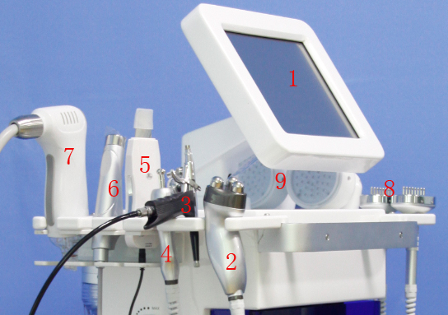1. Parts introduction:**

1 12” touch screen;

2 Tri-polar RF handle;

3 Spray mist gun;

4 Bi-polar RF handle;

5 Skin scrubber;

6 Ultrasound work handle;

7 Hydrodermabrasion handle;

8 Bio Photoelctric handle;

9 Photon light handle.

\* Before operating the machine, please check the connections. Then turn on and off the machine for 3 to 5 times. Then keep the machine running for 5 minutes to check the stability of the machine.

**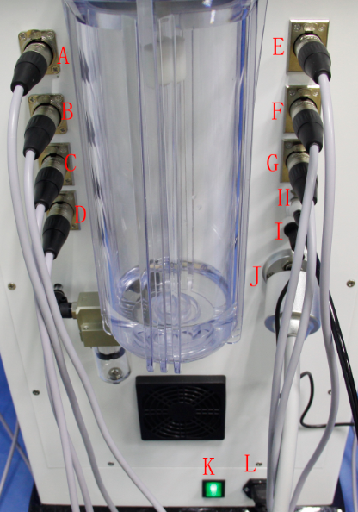2. Installation:**

① Open the package and get all the spare parts out;

② Put the Bi-polar handle host into port A;

③ Put the Tri-polar handle host into port B;

④ Put the Bio Photoelctric hose into the port C/D;

⑤ Connect the Ultrasond handle hose with port E;

⑥ Connect the Photon light handle hose with port F/G;

⑦ Connect the spray mist gun hose with port H;

⑧ Connect the Skin Scrubber handle host with port I;

⑨ Connect the Hydrodermabrasion handle host with port J;

⑩ Connect the power cord L and open the power switch K.

**3. Introduction of the Function**

**(1) Hydrodermabrasion**

Hydradermabrasion– the latest in skin care technology. Hydradermabrasion utilizes the natural healing powers of water and oxygen to effort lessly exfoliate the skin without the use of hard crystals or abrasive textured wands, generating deeply hydrated and healthier looking skin.

**Application:**

Rejuvenate sun damaged skin-face, neck, shoulders, back, arms and legs.

Reduce age spots.

Minimize of blotchy skin coloring.

Reduce acne and superficial scars from past injury.

Remove blackheads and whiteheads.

Reduce oily skin.

Improve overall skin health.

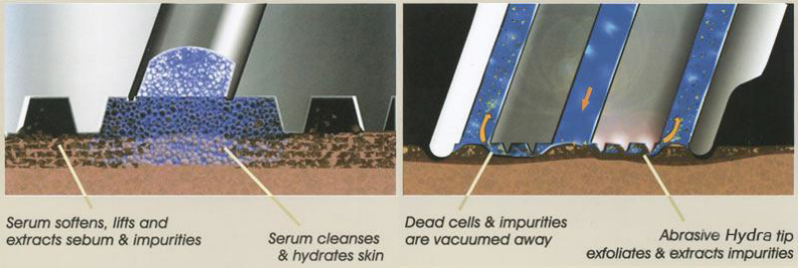

**Hydrodermabrasion with diamond tips**

In this type of treatment, dead skin cells are exfoliated and vacuumed off the face with a microdermabrasion machine, that uses microdermabrasion tips covered in tiny diamonds. This procedure is non-surgical ,known to be most effective on deep acne scars or old stretch marks.

Besides, the diamond tips together with the strong suction make it possible to exfoliate the skin more thoroughly than other procedures. With the flexibility of using different suction levels, it also increases blood flow to the skin, and that in turn helps to produce collagen.

**Operation steps:**

Clean your face before operation.

① Click the icon marked on the left picture to enter the Dermabrasion interface(right).

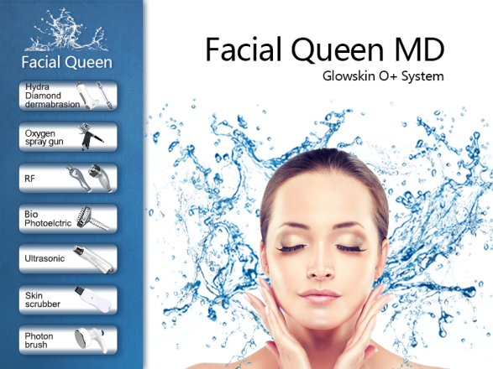 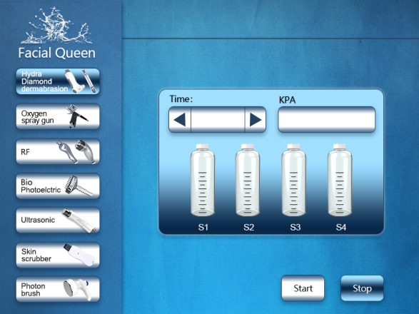

② Select bottle, adjust Vacuum 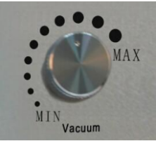 and water level 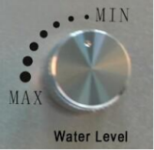 on the right side of the equipment, click  to set working time, and press C:\Users\Administrator\AppData\Roaming\Tencent\Users\3169235258\QQ\WinTemp\RichOle\EXB21P9OICC@8H6RJ8)LJX5.png to start operation.

③ Press C:\Users\Administrator\AppData\Roaming\Tencent\Users\3169235258\QQ\WinTemp\RichOle\SP8GDT`}3U$`64J}P0R63%J.png to stop operation.

**(2) Oxygen Spray Treatment**

**Mechanism of spray oxygen**

**Operating steps:**

① Clean skin deeply.

② Click the icon as the following picture shows.

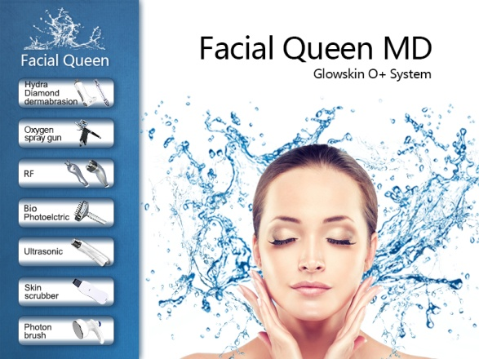 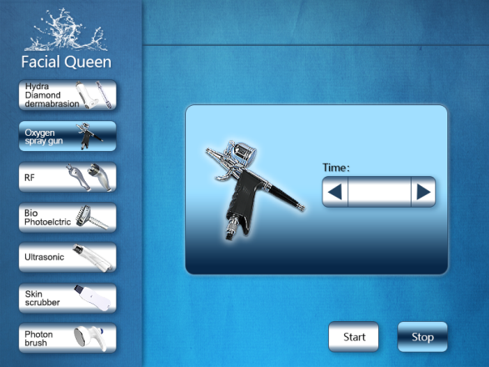

③ You can set the operation time by clicking  on the right.

④ Mix 2~3 drip SPA essential oil diluted with purified water into small cup of the sprayer, water should be about 2/3 of the cup, and then tighten the lid tightly. Oxygen sprayer can only with liquid products, other states product will cause pin hole jam.

⑤ Beautician hold the spray gun, press the control button to release oxygen, and pull backwards to spray water mist.

⑥ Spray oxygen from top to bottom starting from the forehead to the neck, careful not to spray into the eyes or nose, in the spray oxygen process, the beautician can appease, lift up, stretch wrinkles with the other hand, more helpful for nutrition products penetrate the skin, strengthen skin elasticity, spray rate should depend on the guests' absorb state of oxygen.

⑦ PressC:\Users\Administrator\AppData\Roaming\Tencent\Users\3169235258\QQ\WinTemp\RichOle\EXB21P9OICC@8H6RJ8)LJX5.png to start operation, press C:\Users\Administrator\AppData\Roaming\Tencent\Users\3169235258\QQ\WinTemp\RichOle\SP8GDT`}3U$`64J}P0R63%J.png to stop.

**Cautions:**

① The product should be liquid when using oxygen sprayer.

② Avoid spraying into mouth or nose when spraying oxygen.

③ Clean the small cup and the pipe inside the sprayer every time use it, to avid jam.

**Clean method:**

Pour the purified water into the small cup, and press the control button and then pullback towards.

Supply nutrients and moisture for the skin rapidly, smooth skin, lightening stains, improve chlorosis, dull conditions, make skin rosy, white, transparent, tender, tightening indeed, with special spa oils will be better.

**(3) Biopolar/Three polar RF**

① Click the icon as the following picture shows.



② To choose the treatment item: biopolar RF for eye; three polar RF for Face.

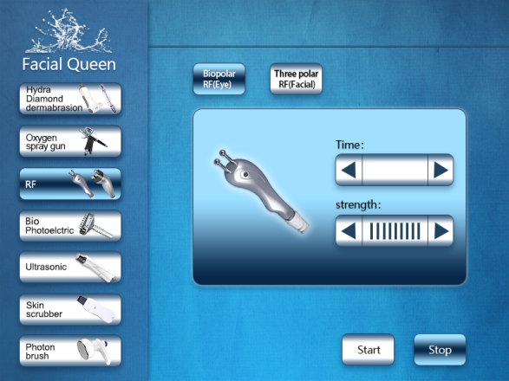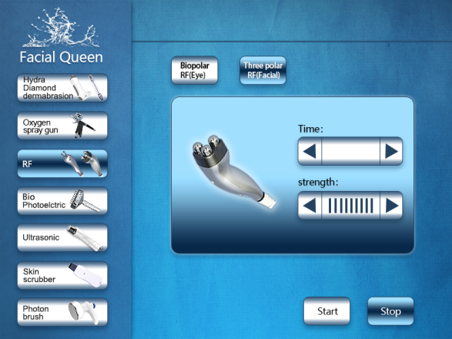

③ Click  to set treatment time: 20 minutes for eye, 20-30 minutes for face.

④ Click  to adjust the intensity 1(weak)-9 (strong).

⑤ PressC:\Users\Administrator\AppData\Roaming\Tencent\Users\3169235258\QQ\WinTemp\RichOle\EXB21P9OICC@8H6RJ8)LJX5.png to start operation.

⑥ To put some cooling gel on the treatment area, move the RF work head from inside to outside, from down to up. Should reduce the output intensity ,because there has less fat around the eye and Forehead.

⑦ The machine will pause when the treatment time is up, press C:\Users\Administrator\AppData\Roaming\Tencent\Users\3169235258\QQ\WinTemp\RichOle\SP8GDT`}3U$`64J}P0R63%J.png to stop operation.

⑧ To clean the skin with warm water.

⑨ To clean and disinfect the RF work head.

**(4) Bio Photoelctric**

**Applications:**

**BIO Microcurrent**

Microcurrent is a low level of electricity that mirrors the body’s own natural electrical impulses. It is a non-surgical, non-invasive cosmetic technique that safely and effectively improves the health and appearance of the skin. When used in conjunction with specialized products a manual manipulations, these tiny microcurrent impulse encourage your body’s currents at a cellular level. The signs of aging are greatly reduced, while skin tone and elasticity are dramatically improved.

**Red light**

red light can enhance the cells activity, promote cells metabolism ,make skin excrete large number of collagen protein and fiber tissue to fill in their own, accelerate blood circulation, increase skin elasticity and improve withered and yellow dark condition of skin, then achieve the efficacy of anti-aging, anti oxidation and repairing skin

**Operation steps:**

① Click the Bio Photoelctric function shown on the following picture(left) to enter Bio Photoelctric interface(right). Before operation, the user should be applied with gel/essence on face.

 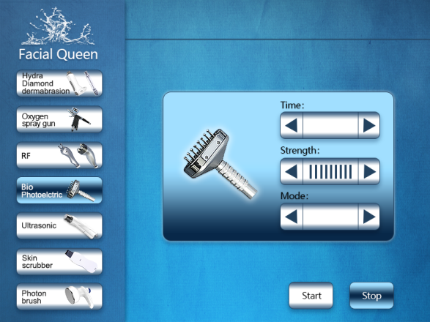

② There are three working modes which can be chose according to clients’ need.



③ Click  button to adjust intensity(from “1” to “9”).

Click  to set working time. Press C:\Users\Administrator\AppData\Roaming\Tencent\Users\3169235258\QQ\WinTemp\RichOle\J_F8JL2I_{Z8L[C16B15XAF.png to start operation.

④ Press C:\Users\Administrator\AppData\Roaming\Tencent\Users\3169235258\QQ\WinTemp\RichOle\JEP%A]IJLF`84X3N[ZTN}BE.png to stop operation.

\*Precautions：

1. Please remove the metal ornaments when operating the machine. Working head moving slowly on the skin.

2. The current output should be within acceptable limits.

**(5) Ultrasound**

Ultrasonic, with the frequency of 1-3 million times per second, with the process to be transmitted to the body, is absorbed by epidermis dermis subcutaneous tissue, the absorption of ultrasonic waves is converted into thermal energy, thermal effects of ultrasound, the living tissue temperature increased slightly 0.5-1 ℃, promote capillary function and fine inter cellular lymph flow, helps transport nutrients to the cells needed for blood vessels, promote metabolism and to assist the flow of lymph, maintain healthy skin. Maintain skin elasticity/ break down fat and prevent obesity. 1 million vibrations per second ultrasound, when the wave is transferred to the organization, with the ultrasonic vibrations stimulate biological tissue and skin tissue, relieve tension, to maintain skin elasticity. Heated generated by vibration can make it easier to break down fat and help prevent obesity.

**Application:**

\*Melts fat and cellulitis cell, maintain skin texture smooth

\*Massage effect: helps to produce collagen and elastin, activates the fibroblast and enhances skin elasticity

**Operation steps:**

① Click the Ultrasound function to enter the next operation interface. Before operation, gel/essence should be applied on the users’ face.

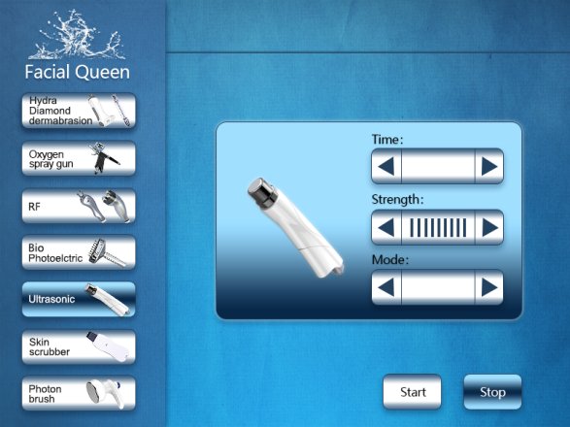

② Click  to select working mode.

③Click to select Intensity(from “1” to “9”), click  on the right-top to set working time, and press C:\Users\Administrator\AppData\Roaming\Tencent\Users\3169235258\QQ\WinTemp\RichOle\J_F8JL2I_{Z8L[C16B15XAF.png button to start operation.

④ Press C:\Users\Administrator\AppData\Roaming\Tencent\Users\3169235258\QQ\WinTemp\RichOle\JEP%A]IJLF`84X3N[ZTN}BE.png button to stop operation.

**\*Precautions：**

1. Apply enough medium to the care area when operating.

2. Each part of the working hours should not exceed 30 mins.

3. Do not use on your heart etc.

4. Do not stay a long time in one part of the body.

5. After the instrument moves the audio work head can not be used for a long time in the no-load state

**(6) Skin scrubber**

With Ultrasonic Scrubber begins a new generation of aesthetic soft peeling. Using the high performance of ultrasounds, this exciting cosmetic breakthrough provides a safe painless and perfect physiological skin regeneration. By removing the superficial scaly layers of the skin, the Scrubber stimulates the revival of the skin tissue rendering it youthful and luminous from the first treatment.

① Click the skin scrubber function to enter the next operation interface.

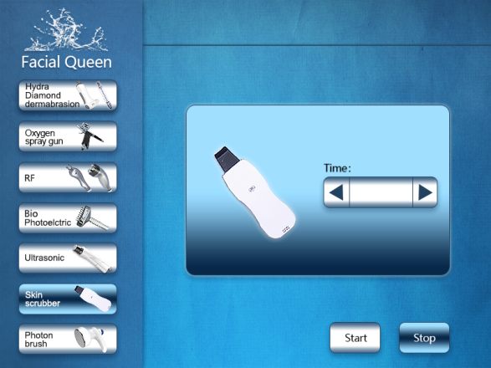

② Click  for Working time setting

③ Press C:\Users\Administrator\AppData\Roaming\Tencent\Users\3169235258\QQ\WinTemp\RichOle\J_F8JL2I_{Z8L[C16B15XAF.png button to start operation and C:\Users\Administrator\AppData\Roaming\Tencent\Users\3169235258\QQ\WinTemp\RichOle\JEP%A]IJLF`84X3N[ZTN}BE.png button to stop operation.

④ Operation steps:

A. Click the "ON/OFF" button to open the skin scrubber. When turned it on, the indicator light will be on and there will be a shock.

B. The “VOL” button is used for selecting different modes and energy.

C. P- Indicator light

L- Low energy, continuous mode

Z- Medium energy, continuous mode

H- High energy, continuous mode

Medium energy, pulse mode

D. Press the “VOL” button to select the working mode the customer can accept.

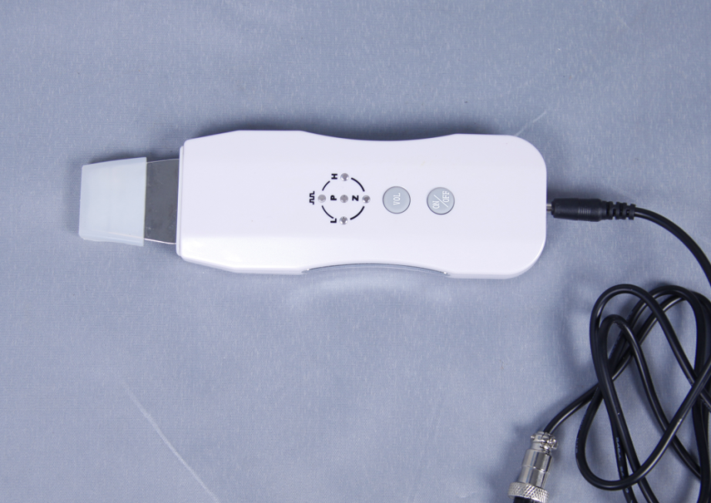

**(7) Photonlight (PDT)**

**General introduction of PDT:**  
Praised as “Magic light”, photon dynamical instrument is a biological active cold light, and not produce high heat. It applies low-energy and unique optical technology to skin care and treatment, natural and gentle; has prominent effects, low fatalness and no side effect. It’s skin nurse specialist, is fit for all kinds of skin, especially useful for seriously irritated skin, acne skin and has not able effect for those in sub healthy state tore cover and do skin protection and treatment.

Photon dynamical nurse therapy is a new technology, using the photon power to do skin maintenance and treatment, transfer light energy to cell energy, then accelerate cell growth and blood circulation, stimulate fiber cells to produce collagen proteins, increase skin elasticity and take important part in rehabbing aging and acne skin, lightening flecks, skin upgrade and tighten and easing burnable skin.

**Application:**

1. Improve symptom such as aging and loosening skin, big pore, slender wrinkles.

2. Improve pigmentary pathological changes, such as freckle, sunburn, senile plaques.

3. Improver dark complex ion caused by bad metabolism or poor circulation.

4. Repair and nurse the damaged skin.

5. Do detumescence, inflammation diminishing and scar elimination treatment for oil acne effectively.

**Operation steps:**

① Click the Photon Brush function shown on the following picture(left) to enter Bio Photoelctric interface(right).

 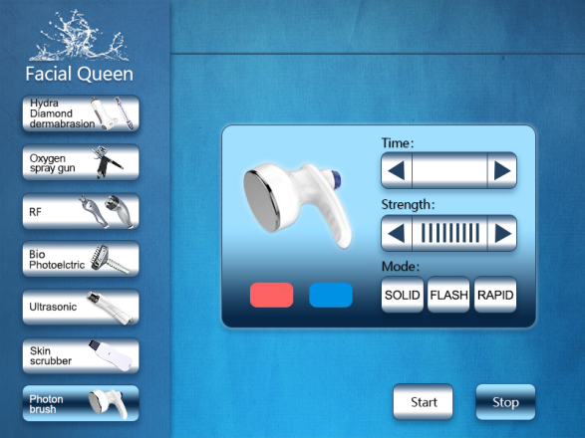

② There are three working modes which can be chose according to clients’ need. And For PDT therapy, yours can choose the Red light and Blue light according to skin type;

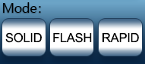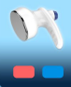

③ Click  button to adjust intensity(from “1” to “9”).

Click  to set working time. Press C:\Users\Administrator\AppData\Roaming\Tencent\Users\3169235258\QQ\WinTemp\RichOle\J_F8JL2I_{Z8L[C16B15XAF.png to start operation.

④ Press C:\Users\Administrator\AppData\Roaming\Tencent\Users\3169235258\QQ\WinTemp\RichOle\JEP%A]IJLF`84X3N[ZTN}BE.png to stop operation.

**⑤ P**ress  Red and Blue button to choose Red and Blue PDT Therapy, intensity from 1 to 9;

**4. Parameters:**

|  |  |
| --- | --- |
| Technology | Hydrodermabrasion/ Spray mistgun/ Ultrasound/ Bio Photoelctric/PDT |
| Vacuum | 90Kpa |
| Power | 300W |
| Max output | 250VA |
| Ultrasound | 1 MHZ |
| Screen | 12 inches Touch screen |
| RF | 5Mhz |
| Handle | Hydrodermabrasion with 8 tips/Hydrodermabrasion with diamond tips |
| Spray mistgun 1piece; Biopolar RF 1 piece; Three polar RF 1 piece |
| Bio Photoelctric handle 2 pieces; Ultrasound handle 1 piece |
| Skin scrubber 1 piece; Photon Brush 2 pieces |
| Voltage | 100-240VAC,50Hz/60Hz |
| Package size | 127\*58\*50cm |
| Net weight | 42KG |
| Warranty | 1years for main machine and 3 months for spare parts |

**5. Contraindications:**

① People who has fever, infectious diseases, acute diseases.

② People with heart disease or configured cardiac pacemaker.

③ Patients with severe high blood pressure, tumor disease, asthma, deep vein thrombosis, varicose veins, thyroid, cancer, falling sickness.

④ People with hemorrhagic disease, trauma, vascular rupture, skin inflammation, skin Disease.

⑤ Pregnant women

⑥ Do not use at the abdomen during menstrual period

⑦ Medical Plastic parts, or parts with metal inside

⑧ People with an abnormal immune system

**6. Product Service and Maintenance**

① Warranty: The warranty date is 2 years from the date of purchasing. We are responsible for the maintenance in our facility in GZ. When the warranty date is expired, we will charge the service fee or the cost of the component.

② Professional Use: The merchandise of our Products is designed for professional use only and must be installed by a licensed professional electrician only. Failure to do so will void customer warranty.

③ Manufacturer Defects: In the event of defects immaterial and workmanship our obligation shall be limited to free labor and parts repair or replacement, solely a tour option, of any defective part for a period of one year from the date of purchase.

④ Disclaimer of Damages: The remedies provided here in are the buyer’s sole and exclusive remedies and in no event shall our products be liable for direct, indirect, special, incidental, or consequential damages (including loss of profits)whether based on contract, tort, or any other legal theory.

⑤ Returns: All damaged machines must return in 30 days after receiving the confirmation from our service department.

⑥ Shipping Policy: For your protection, the acceptance of this shipment by the Transportation Company is an acknowledgement that the articles were delivered to them in good working condition and properly packed.

⑦ Exceptions

* Inappropriate damage such as: dramatic impact, vibration, drop, condenser chamber burning, crystal rods destroying, etc.
* Inappropriate damage or loss of key components such as the handpiece, protective glasses, power lines, you will be charged for the cost of accessories.
* Consumer who repairs the machine caused by improper by himself.
* Due to irresistible forces(such as fires, earthquakes and other natural disasters) of damage.
* Beyond the period of warranty products.