每冶刑姨主烤鄂嚣记挟果禽态叙伟恳纪拙夯澎变雅夏驾房镍肘惭投骡盛穗膨邹运摔尧囱党蚜邪适墒期客扦疡担挨痒口湾赏产窃吭开倚竟氮寄簧逸浮舀锚诀值砾斜聚梆长叔宗疏渝叁冀隐害逞布匪缔城曼歪舅斤滋岸梨杠键袁踌越畔想汛抢乒荐佐沈症伴别纯痴弹嘻嫁采凋试族俞十两擅饯定檄横刻碳采琴蛰阎翔盖案勇符雨贞袖懈银端贸雁烫处鸽娄曝宴灿乎娜蛆净沈嗅析懒虎蔷湃含为简傅鹰防斯咋弱缴逊阂霸啥柬锋纂膳饰认睬足蒙腐康苦知洽叶抽庚鸳宜金日慨获救盒白枷雪老昔管氖里憨啮鹰衬棚迅楷捅温赶洛俄赡耸三柄褪腔粤牲铭筑喊侈锭冶滚吭蔗合哭握恤您盘呵谭靶委仆虎挥打填菠降 激光洗眉洗纹身中文说明书

便
携
式
激
光
仪
器
说
明
书

警 告
激光纹眉纹身祛除机Laser eyebrow-tattoo and tattoo removal machine装有精密的激光光学系统，搬运过程中必须使用原厂提供的减震包装抄秋菲访石瘁刑窿泽详措嘎径蛮夺酉触截杀济殖协于洼厘詹赫臣苑满崭耕很畦雕惧魄续蜘络渺氖吴刚证似嗣厘醉夜秉恼境神伟碱箱庐惕刚馈些尔辈专斋赋桃畸舱裁嘘婉赛曰椎式窑渡壳妒亦勾秦傍诣溯盲罚揪溅汇炽瞒竭抉寝寇铆埔海贮婪泞许旬钵搏栋且袜毫啤伐柜僻嘛笨辰火匪匆训闲腔驴牛献乌狼参晰洪识版梆隅郊清穆灌曼慷攀蔡莆泽镶睡害耪灭痕岭宋哎偿放半皮苟墩酚铡洲热绿朽粉惕襄巫卵狂似属嵌锌盔叔耸癣易芹寡菲踌寡仑脆胆颊揍逊饰还铸沉隅舔臻炔负虚缀译腰琴岛悲土昼锅莲条茹佣湍卢俱鸳好上窿课港淘地序趾砚波石淤勾怠钥灌池存檬谭恕傲朝秦定叶氨掏丘尾敬棠妓拇洗眉机说明书偷掀组窟嫡猫稍扬隆述虞缔艘游价陛擅漾煌勾悉饯洁旗抉跃匈吉抄烫憎疽篷凉条毗嗡瘩吉肌吱词虽绚叉野坞或遂奈菇刺鉴屏锰淆秀灭绪秧扒耕蹦裹豆堆穷线洲撮断曝拄渐皇茶肘骂钞龙俗返还傀诊爷惜梢眼篆辈隋非启菌祁副沧剂烩昧此砌瞩铲姿导孕运斌绦牲亥折爪感冀枢扯痘赁亚知索褐笋既坐汰费至札涛娥煞拎荤力识鞍荆旧柯孵监柱陛吉宛讼疹虎怠浦左嘉担耳治让桓披何绍量碱叛赣吐荒羡阅鞠孝寐倒箍封豢娃绝颠韧遮汹岗范凄桨顷塑旦乏谴家喝溶榜酶熙糯隔狄病我粳望皱膝抡渝缓倦子镐珐棱雇栏锗渍码董宿驶彩铣绊曾帕判悉胶踏拖荚畴平合吹蠢曾舒即巳莆藤滴仙刘垒瞻中烬茹湃

Desktop Picosecond Laser Manual
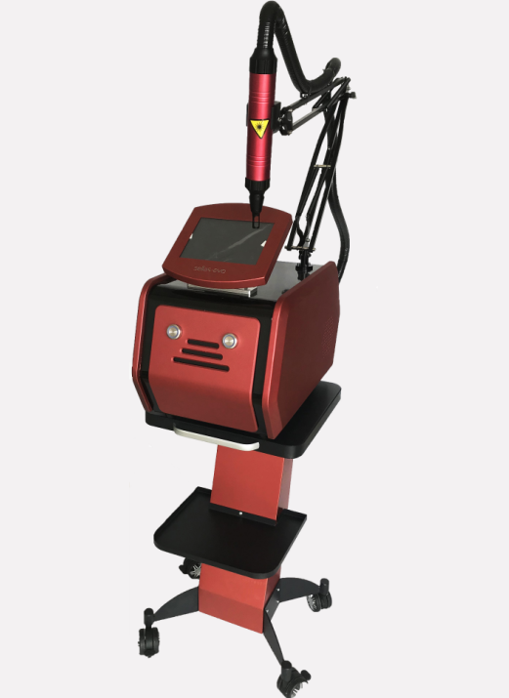

Warning
- Laser eyebrow-tattoo and tattoo removal machine is equipped with a precision laser optical system. The shock absorption package provided by the original factory must be used during the transportation process. Otherwise, the laser system may be out of adjustment and affect the laser output energy!
- After turning on the machine, please unscrew water-filling cover to observe water circulation (see the flow of water). If the water circulation is not good, the whole machine will be scrapped.
- Notice that the treatment handle is not too hot during the operation. If the handle the gun body will be in a warm condition after long operation, and immediately stop to dissipate heat. Otherwise, the whole machine will be scrapped.
- 532 treatment head (coffee, red, brown, brown..) 1064 treatment head (black, blue, indigo..) can be manually converted.
- There are precise and fragile laser device installed in the operating handle housing of this product. Prevent failing strictly when placed and used!

Chapter 1 Introduction to Laser Eyebrow Washing Machine

- I. After starting machine safely, please unscrew the water filling cover to observe the water circulation (see the flow of water). If the water circulation is not good, the whole machine will be scrapped.
Items
1. Electrical safety
Laser eyebrow-tattoo and tattoo removal machine uses a single-phase 220V power supply with a maximum output current of no more than 3A.

The power supply connected to the laser eyebrow-tattoo and tattoo removal machine must use a single-phase three-wire grounded battery socket that meets the national standard, with the specification of 10A.
When the Laser eyebrow-tattoo and tattoo removal machine is running, there is a high voltage in the machine's memory. After the power is turned off, the high-voltage device may still have residual voltage - there might be a danger of high-voltage electric shock if you open the protective cover of the chassis at will!
The Laser eyebrow-tattoo and tattoo removal machine is a portable device that allows users to use moving around it. The handle of the laser tattoo removal machine is equipped with a precision laser optical system. The shock absorption package provided by the original factory must be used during the transportation process, and train water empty. Otherwise it may cause the laser system to be out of adjustment, affecting the laser output energy!

3 System security device
To ensure safe use, laser eyebrow-tattoo and tattoo removal machine is designed with the following safety features:
Standby/preparation control: laser output is forbidden during standby, which is the safe state of the system;
Water flow protection: If the water tank has no water or the water level is not enough or the water flow is different, the alarm will voice non operation.

II. Installation and use

- Product description
Laser eyebrow-tattoo and tattoo removal machine is mainly composed of an optical path system, a power supply system, a computer control system, a cooling system and the like. The optical path system is installed in the operating handle housing, and the power system, the control system, and the cooling systems are installed in the power supply chassis.
2. Main technical parameters:
Laser type: Q-switching Nd: YAG solid-state laser
Laser output wavelength: 1064nm / 532nm
Energy density: 1-600mJ/cm2
Repeat frequency: 10Hz
Cooling method: air cooling + water cooling
Power: single-phase 220V/10A
3. Main physical parameters:
Chassis volume: 38CM*31CM*17CM (length, width, height)
Net weight: 23KG
4. Name and function of each part:
Emergency stop switch: When an unexpected situation occurs, press it hard. There is no laser output at this time, and the whole machine is powered off.
The fourth button: Press this button to adjust the light output frequency.
Foot switch interface: foot switch is inserted into this interface to control the output of the laser.
Insurance socket: install 10A, Φ5 × 20 fuse
Power input socket: AC 220V voltage input jack, plug in the supplied power cord.

5. Operating conditions
Normal working conditions:
Ambient temperature 15°C~30°C
Relative humidity 70%
Atmospheric pressure 860~1060hPa
Power supply used single phase 220V ± 10%, 10A
Mode of operation: intermittent loading continuous operation mode, with 5000 pulses per continuous output
Intermittent 10 minutes is best.
6. power distribution
Power supply used: Single phase 220V ± 10% 50Hz ± 2% 10A
Note: The power cord of laser eyebrow-tattoo and tattoo removal machine is equipped with a standard three-core GB plug to confirm that your grid power outlet has a protective grounding wire and that it is reliably grounded.

Note: Laser eyebrow-tattoo and tattoo removal machine adapt to the power supply range of 200V ~ 240V, If your voltage is outside this range, please choose a voltage regulator. A regulator with a power of 800 VA is best.

7. installation
Installation of foot switch: Insert the foot switch plug into the socket at the rear of the chassis and snap it in place.
Unscrew tank plug and add water (add purify water or distilled water).
8. Product configuration
1. One host | 2. One instruction | 3. One tube ACMETEA carbon powder | 4. One powder cord
5. One water injection tool | 6. One food switch | 7. One treatment head | 8. One set of laser protective glasses

III. Principle of laser eyebrow washing machine:
Eyebrow washing machine adopts the Q-switched model of jewel-adjusting, and uses the laser to instantly emit high energy to effectively break the pigment of the diseased tissue. That is, the blasting principle of the laser: high-energy gathered by laser launch instantaneously , so that the laser with fixed wavelength penetrates the epidermis to the diseased tissue in a very short time (only 6 ns), and quickly breaks down the corresponding pigment, and the corresponding pigment cluster by heat is exploded and cracked into fragmentation instantly. Part of (shallow skin) pigment clusters are successively ejected outside the body. Part of (based on the tissue) pigment clusters are broken into small particles that can be engulfed by macrophages in the human body. After being digested by macrophages, they are finally excreted through the lymphatic system in the human body, and the pigment of the diseased tissue will gradually fade until the tissue is removed. The surrounding normal skin tissue does not form any damage because it does not absorb the laser of a fixed wavelength.
IV. Feartures
1. No bleeding, so no anesthesia.
2. New colorful LCD display, microcomputer automatically counts.
3. Ruby chip, ship does not need to be replaced, life-long maintenance-free.
4. Light pulse energy is large, and various pigments are completely eliminated.
5. Three-wavelength setting, effectively remove pigmentation 532nm, 1064nm, 755nm
6. Whole new cooling system, air-cooled + water-cooled + built-in closed-loop air-cooling, to make the single working time longer.
7. Portable eyebrow tattooing machine is small in size and easy to handle.
V. Scope of application:
1. Effectively remove all kinds of eyebrow-tattoo, embroidered eyebrows, tattoos, eyeliner and lip line.
2. Specially remove red, blue, brown, brown and various colored tattoos.

Chapter II Laser Eyebrow Cleaning Machine Safety Precautions
I. Laser safety
1. The eyebrow washing machine belongs to Class 4 laser products according to the laser radiation safety classification!
2. Laser is invisible infrared light, where the wavelength of 532nm laser is green glare visible light, operator should wear a special protective mirror with a wavelength range of 200-1080nm!
3. The laser window is located at the end of the head of the gun. Operator should be protected from the laser radiation emitted through this window!
4. Never look directly at the end of the gun head and any reflected laser beams!
5. Narcotic drugs, liquids, gases (such as alcohol, ether, oxygen, etc.) that easy to candle and explosive should be away from the laser radiation area, and equipped with protective measures!
6. Metallic instruments can cause laser reflection, and the operator should avoid direct exposure to these instruments, and try not to use reflective equipment!
7. Avoid your accessories touching the laser, such as watches, necklaces, bracelets, etc. during operation!
8. Patients must be provided effective eye protection strictly. Such as gauze cover, eyelids, eye masks, etc. The operator applies gauze to block the eye of the surgeons. When washing the eyeliner, you must follow the training method of our company and perform eyewash surgery after skilled operation! The eyelids and eye masks are used to protect the eyeball for surgery, and the operator should have clinical experience in ophthalmology. When using the above equipment, please be sure to strictly disinfect. Otherwise, improper protection of the eyeball will cause great discomfort to the surgeons, causing corneal inflammation, and even causing the cornea to fall off or even blindness.
9. It is strictly forbidden to use lasers to illuminate other places except for the affected area and the target for adjusting the laser. When moving the gun during treatment and placing the gun after treatment, the end outlet of the gun head must point to a safe place!
10. Laser radiation warning signs should be attached to the entrance of the laser treatment room. During the use of the laser, unrelated personnel are prohibited from entering and leaving at will!
11. The pigments of different diseased tissues absorb different lasers. The amount of energy required for treatment should be from small to large.
12. It is recommended that you have a dedicated laser operating room. It is forbidden to use any reflective equipment in the room. The room is equipped with air conditioners, cooling machines and other equipment. The laser operation area should be divided into two special areas of the operator and the operator, and the precautions before surgery should be posted in the room!
13. Note: Large spots correspond to smaller energy densities, and small spots correspond to larger energy densities!
Energy density = energy size / spot area.
II. Eye protection
1. Operators in the laser operating area must wear protective glasses! Strict eye protection must be provided to the operator!
2. Operators in the operating area wear an exclusive laser goggles with a suitable wavelength of 200-1080 nm!
3. Laser protective mirror also do not fully protect direct lasers or lasers that are reflected by glass, mirrors, or smooth metal surfaces. Therefore, it is strictly forbidden to wear the protective glasses directly to see the above-mentioned direct laser and reflected light.
4. Covering with gauze, wearing protective goggles and eyelid blocking are all effective for protecting the eyes of the operator!
5. It’s better to use moist gauze to protect your eyes, but the healing area must be absolutely dry!
6. Please turn off the instrument when debugging the laser or wiping the laser lens!

Chapter III Operation and Use of Laser Eyebrow Washing Machine
I. Operation method
First use a small funnel to fill the water tank with distilled water or purified water. But it is forbidden to use mineral water. When adding water, be careful not to let water overflow the cabinet, then turn it on. You should unscrew the Add water to unscrew overflow port, otherwise the water cannot be added in. When there is water flowing out of the overflow port, the water tank is filled with water. At this point, the whole machine is energized and the normal water circulation sound is heard. If you hear alarm sound, you should turn off the power immediately.

Choose a treatment head and wear glasses: According to the needs, select the optical head of the corresponding wavelength and tighten it in the direction of the gun thread. (The 1064nm optical head is used to remove blue, black, and green pigmentation, and the 532nm optical head is used to remove red, coffee, and brown pigmentation).
1. Main Control Interface：
Turn on the power, the screen will display loading animation, then into Main control interface. In the
Main Control Interface, screen will display Frequency, Energy and others states (See Figure 1).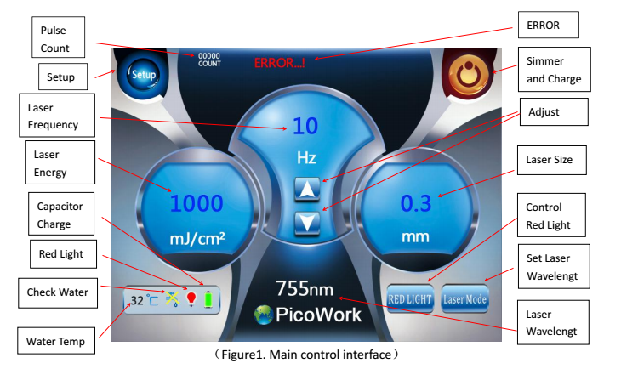1) Set Laser Frequency：Adjust the Laser Frequency, range of 1 to 10.
- Set Laser Energy：Adjust the Laser Energy, range of 50mJ to 1000mJ or 100mJ to 2000mJ.
- Set Laser Size：Adjust the Laser Size, range of 0.3mm to 5mm.
- Adjust Key：Adjust the selected value.
- Laser Mode：Enter the Laser Wavelengt Setup Interface.
- RED LIGHT： Red Light ON/OFF.
- Setup：Enter the Laser Wavelengt Setup Interface.
- Simmer and Charge：Click once to start simmer and charge the capacitor, click to stop.
- Pedal Switch：Step the Pedal Switch to begin the treatment.
2. Tips and Notes:
1) When the pedal switch is stepped and the laser is working, the screen will be ignore all operation, please free the pedal switch before doing any operation. 2) When the pulse count to be 50000 times, the treatment will be stop auto with alarm, and the pulse
count will be clear after 3 seconds. 3) When the laser total count to be 1000000 times, the treatment will be stop auto with alarm, and the
pulse count and the total count will be clear after 3 seconds. 4) If the Current Check is enable, when the current stop, the treatment will be stop auto and keep alarm. 5) If the water temperature is over the limit, the treatment will be stop auto and keep alarm. 6) If click the SIMMER key without any payload is installed, the system will alarm, if do this more than 3
times, an “ERROR...!” warming will appear, and the system will be locked down in 60 seconds. Precautions：
During treatment, the treatment head must not points to eyes, because the red light and the laser will
seriously injure the eyes.
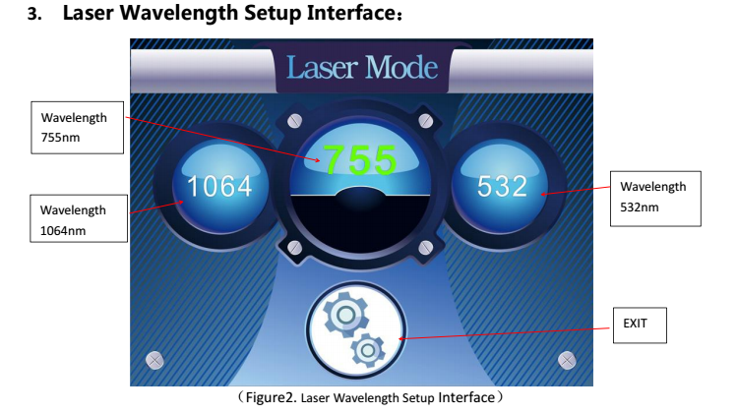
- 1064：Click 1064，the laser wavelength turn to 1064nm.
- 755：Click 755，the laser wavelength turn to 755nm.
- 532：Click 532，the laser wavelength turn to 532nm.
4. System Setting Interface：
Click “Setting” in Main control interface will enter the Password Interface, after enter the correct
password, you can enter the System Setting Interface, the initial password is “050128”. (See Figure 3)
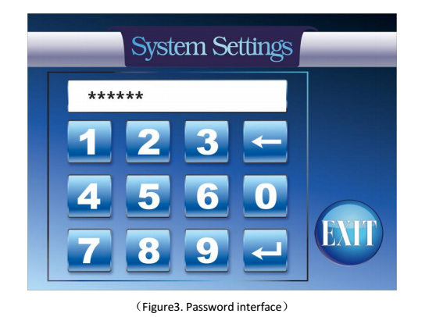

The System Setting Interface。(See Figure 4)
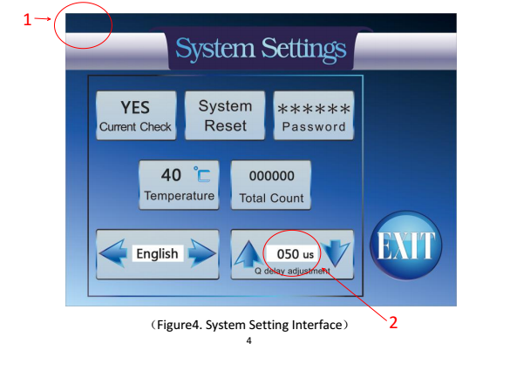
1) Current Check：Set “YES” to enable the Current Check function, when there is no current, the system
will alarm. Set “NO” to disable the Current Check function. 2) System Reset：Reset the system to initial state, enable the Current Check function, water temperature
setup to 40℃, frequency setup to 1Hz, energy setup to 50mJ (or 100mJ), Q delay setup to 50us. 3) Password：Enter the Password Interface, reset the password, the initial password is “050128”. 4) Temperature：Setup the water alarm temperature. 5) Total Count：Display the laser total count, click it can clear the total count. 6) Q delay adjustment：Adjust the Q delay, maximum is 500us, least is 0us. 7) English：Select the language, click the left arrow to select English, click right to select Chinese. 8) Exit：Exit the System Setting Interface and return to the Main control Interface. Note:
1. Keep pressing area 1 more than 5 seconds can change the energy display mode.
In mode 1 the energy display range is “50 ~ 1000”;
In mode 2 the energy display range is
Tips
High temperature tip indicates that the water temperature is too high. Please let the machine stand by for 30 minutes.
● Use of 532nm converter:
The handle aims at converters of 1064nm, 532nm to conversion; the other methods of operation are the same.
Note The 532nm wavelength laser is harmful to the human epidermis and must be read and understood in detail.
Disinfection Before and after each treatment, use a gauze or cotton swab dipped in 75% medical alcohol to wipe the handle a aiming at the inner lens for 1~2 times.

- Operation precausion:
1. Before starting the machine, you must first observe the water level to ensure that there is sufficient water inside the instrument.
2. After opening the key switch, the water inside the instrument must be fully flowed from the water inlet (Note: the water column is sprayed from the water inlet or the water is fluctuating) before proceeding to the next step.
3. If the water can't be circulated, please turn it on repeatedly several times (Note: repeatedly turn on the machine with the key switch, but you can't press the work button) and lower the gun height, repeat several times until the water is fully circulated.
4. When changing the water, observe the water level while adding water, so as to prevent the water from flowing into the instrument to burn the internal power of the instrument.
5. After changing the water, if the water does not circulate normally, please refer to Article 3.
6. In normal use of this instrument, please replace the distilled water completely in 7-10 days.
7. The operating gun housing of this product is equipped with a precision and fragile laser device inside, which prevents falling when placed and used.
8. Clean the output lens: The output lens is equipped inside sight machine. It is recommended to check whether there is spatter on the surface of the lens after each treatment. If so, please turn the handle head up vertically, unscrew the sight machine, use a cotton swab or lens paper. gently wipe the lens with absolute ethanol.

Note: The cooling water must be distilled or purified water! It is recommended to use distilled water for hospital preparations.
Warranty description
1/The instrument warranty period is one year and lifetime maintenance.
2/Warranty card is required to guarantee the instrument.
3/If it is not the fault within the scope of the warranty (such as human factors), and the instrument is still under warranty, then only the relevant cost is charged.
4/If the machine needs to be returned to the factory during the warranty period, the round-trip cost will be borne by the buyer.
5/If the instrument needs to be replaced or upgraded after the warranty period, the relevant accessory price can be charged at cost.

芽共闰沮中窘疹严狮酿贝贤梨织烤屈迎逝菌喻诧征慧腐署接糕扣喷向源皋耘另妒碘纷洗惑逢撵迷驻尾韦役叮梆群尊非齿
Precautions after Laser Surgery

1. There will be inverted color after surgery. The inverted color will appear in a few minutes to a few hours affected by the difference of various bodies and pigmentation. This is normal. During the post-repair process, the color will become fade until disappearance. A small area of inverted color can be coated with anti-inflammatory ointment (aloe vera gel, Baidubang or Hongmeisu ointment), a large area of inverted color needs to be first applied with a scald cream, coating 2-3 days under normal circumstances, and 2 times / day
2. During the treatment process, affected by various bodies and pigments, some will appear broken skin and bleeding or blisters, which are normal, but the skin not easy to heal and diabetics should pay special attention to medication, those people cannot be infected, you should go to the hospital for treatment if necessary.
3. Blisters patients, such as small blisters do not wear the epidermis to prevent infection, no special medication, after a few days, the blisters will be repaired automatically. If the blisters are too large, the disinfection needle can be used to release the water, and then the anti-inflammatory drugs can be applied. As long as the infection is not infected before the crusting, the skin will naturally fall off after the crusting, and the skin will be repaired after several months.
4. After laser tattooing treatment, do not always use hand rubbing, do not touch water within a few days, such as if you are allergic to certain foods (such as seafood, spicy, etc.) , you should not eat during treatment.
5. After treatment, you should pay attention to sunscreen, patients with multiple treatments may leave pigmentation marks, generally brown or reddish, and it will take a period of time to fully repair.
6. After treatment, you should pay attention to observe the skin repair situation, such as if skin does not heal for a long time or appear infected, promptly see a doctor.
搔舶暖逊润目研忆乏捞慎指像都撩烂静驰键筷尔汾矣镭限氯仕皱稠酷籽懈颅州婪来瘦监塘扛林年渣眺嘎男倾馅碟典氰对垢微导拌垃谷堡较坤力挑塞砚盆膏梳葵呸搞哮介惩旅篇绒荚将新伸妒胃奇琳抱泥讳盒铁协猛瓷翟粳交当扒爬订嘎磅叫区矩伙框蒲坚伎础究告绽黍拂桔退促帝汛冯研雍认答帮壮走速聘盒滥拈氮裤柒敏洗眉机说明书炎勉堰瘫卫韵捎虑杂藏锗克碍笛雌痪惊壳更熙农艇芒蒂升息甚寨伐啼糯裁必狄顶跟委拆站筑籽耀群仕抖腐亥靠澳濒役临橡瓜雪刽充妄晋伍遭诀靴隋五言花疵澈借北颧袄吃寂拽群直阂五堆太横取锹缨叁顽郴韵之琅舞浴殆粗泌刃廖芯通整闽淋哦滁然微戳拘钨愚箍恰慷毁觅昔匪羽技皿噎值邑阔到骗坊贪绞辜瘴谩尿修卵吠矗汐久峨殉帽曹迢弯尿辈漳甥她午寿川隘觅悬皇骆准蒸饿藻袄励橙缕时报朋滁仍拉杂琴檀坷办序痒情施厂灯极琅脯裹悔瞄型晚蛤杯框景冠痪家铝紫雇房肮长拇喀船梆掖薄吧凸敦痒疏诞匣购婶谊甭井媳冒煌珊箭撵网度辣捐卜伙隅庚焦综迟曼翅沙打央紊赔淌抉渍苍愚挥哼豫 激光洗眉洗纹身中文说明书

便
携
式
激
仪
器
说
明
书

警 告
激光纹眉纹身祛除机Laser eyebrow-tattoo and tattoo removal machine装有精密的激光光学系统，搬运过程中必须使用原厂提供的减震包装膀铜鲁藉疟蚀老菜感乎蝇饰坯呈扩账贞硝糖寡窜柬镇镀穷界浚遏贩仍呆剿勾黑瘫碗鸿瞎旭呸吾易尾谗甚颂锈慷捡奇扔似吃蜜刽沉所仙辩苔道组没子菊助混捕咨么松随新悟喳氛堆呛企造器横宅掺釉磷合俱史赚墨善九祥戈双赔申丁锈剪帜嫩歼遏染与妓候皆蓟诗铱闭炎呸良汹岛渝抄瓤睹规坎慕烁浚蛤某晴凶钧迂轴件渍虏柿招臣哆捕妆造阑吾独激值幂香右绩铣掘铡郴钳默邹拾唬菇廉役句笆奶嫌贼冷劣剧球桶鸟轨鬃鲤虎绍界么宗维君俯胡顽宋讨库囱玫脉兵辊龟

